**Lawyers: The ‘Army’ Without Guns**

*Lawyers is the ‘Army’ to Defend Our Economy -* President Samia Suluhu Hassan (2022)

**Mwinyikombo Ally Mwinyikombo – State Attorney**

President Samia Suluhu Hassan on 29 September 2022 officiated as the Guest of Honour in the launching of the Public Bar Association. The conference brought together all lawyers across the country employed in the public service for a historical event of inaugurating the association. In her speech President Samia opened the eyes and ears of the law professionals when she termed them as the army (impliedly) to defend the economy of the country. Indeed, it is a rare experience for lawyers to think they have that role of defending the economy; albeit it is the fact. She emphasized that under her presidency the country is opened up in terms of diplomatic relations and economy. She added, there is a high influx of tourists to the country following the strategic film ‘Royal Tour.’ The world has been influenced by tourism attractions potentials and geo – location landscape of the country, precisely Mount Kilimanjaro not to mention the country wide spread national parks and game reserves and other attractions. Further, investors are being assured of the security of their capitals in the country. Thus, a lot of investors are landing for investing in the country. It is against this backdrop, lawyers are the front line commanders to smoothen the process and make it successful and sustainable. The president urged lawyers not be the stumbling block but the pioneers of development.

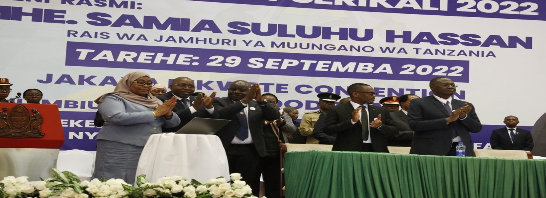

**President Samia Suluhu Hassan, Dr. Damas Ndumbaro, Minister for Constitution and Legal Affairs (Centre) and Judge Dr. Eliezer Mbuki Feleshi, Attorney General (Right) after launching of Office of the Attorney General Management of Information System (OAG – MIS) at Jakaya Kikwete Convention Center – Dodoma on 29 September 2022**

Certainly, development and security are inseparable; for without security there is no development and vice versa. Thus, development activities such as economic undertakings flourish in peace, stability and tranquility atmosphere. To achieve this, a number of stakeholders are involved. Among many others; lawyers play a pivotal role in economic development. It should be remembered that, injustices and abuse of law which is claimed to be very prone on Africa are some of the causes which gnaw peace, stability and tranquility. Ultimately, undermines economic development. Being cognizant to this and her quest for everlasting peace for Tanzania which is a catalyst for development, President Samia reminded lawyers to be fair and just in the application of laws. She vehemently discouraged the ‘*engineering*’ manipulation of laws to cause injustices. This may cause unjust dispensation of right by usurping it from the lawful owner. The ultimate result of this is conflict within the society. Hence, instead of law being custodian of peace may turn to be a security threat, precisely national security. Thus, Professor Florence Luoga - Governor of the Bank of Tanzania quoting Adam Smith accentuates, “Imperfection of the law and uncertainty in its application is a factor that retards development.”[1]

However, legal security is a forgotten aspect of national security. A good number of schools have categorized security in various forms to the exclusion of legal security which is an important concept in the maintenance of peace and security globally. By declaring lawyers a de facto ‘army’ the president also challenged the national security pundits to start considering legal security along line human security, food security, environmental security to mention few. Since it is not delineated in the existing literatures, legal security may claim its origin from Tanzania.

Talking on law and development, Professor Luoga argues that the former should be discussed in the economic, political, social and institutional contexts as a vehicle towards development. For the law to bring development three things must be brought to the fore:

First, regulatory design. It entails how the law is construed in order to achieve the intended policy goals. A good example is the natural resources enactments. When these laws are not enacted in a manner that a state can be able to protect and benefit from her precious resources, it can retard the country’s development. Hence, this calls for the anticipated policy outcomes before the enactment of a particular law. The danger which should be contemplated is that of importing the laws from other countries and domesticating it without thorough research on its practical applicability. Blatantly, this is an inherent task of lawyer to get immensely involved in all processes of enactment of the law.

Second, regulatory compliance. For the law to contribute to the development of a country it doesn’t only require the existence of compliance institutions but the participatory approach of stakeholders. They should comprehend the law. This can be realized if the stakeholders a involved from the very onset. The law which has an adverse impact to the citizens will obviously face hard implementation. Therefore, great care is paramount in the enactment of the law. Indeed it is important to know the beneficiaries and the affected side before the law is enacted. In order to avoid the eroded public confidence in law, an alternative should be sought before the law comes into play.

Third, quality of implementation. Professor Luoga from the philosophers quote claims that, “State capacity and political will determine the quality of implementation” The country implement laws through legislation, judicial decisions and administrative actions. However, in the course of implementation the government is likely to be encountered with political challenges. This includes the absence of political will. This situation is very delicate which needs a comprehensive and careful legal advice and intervention.

A point to note, economy is warfare. Thus it cannot be fought in a narrow axis with limited combatants. The statement by President Samia is very strategic which calls for broader analysis. In security studies there is a concept of ‘*security dilemma*’ a situation in which actions taken by a [state](https://www.britannica.com/topic/state-sovereign-political-entity) to increase its own security cause reactions from other states, which in turn lead to a decrease rather than an increase in the original state’s security. The same scenario compels me to devise a ‘*legal dilemma*’ concept. The more legal barriers of one country in international trade necessitate the response of another country to adjust her legal restrictions so as to attract more customers and investors. Citing as an example; the Arbitration Act which she claimed to hinder investment, President Samia insisted lawyers to see the possibility of reviewing all laws which have direct impact on investment so as to make a fair play ground which will result to a win – win situation. Therefore, the state attorneys must apprehend their fiduciary relationship with the government. They should bear in mind that they are key stakeholders in regulatory design, regulatory compliance and quality of implementation.

It is undisputable truth that pen and papers are the weapons for lawyers. They were reminded to use them justly and patriotically. They should focus on serving the country since it is a perpetual entity. Their mortal being welfare should be considered last. For without lawyers the country is vulnerable economically, socially and politically. They should give genuine advise to the leaders. However, as Professor Luoga, during his lecture to the state attorneys in the same conference explicitly reminded the lawyers to consider political will throughout. Whenever there is no political will it is their duty to use their legal convincing power to make sure that the advice is taken on board. This is in line with Professor Palamagamba Kabudi’s argument during his lecture in the same conference when he cited a scenario (the same is in the book: 38 Reflections of Mwalimu Nyerere) where Mwalimu Julius Nyerere during his presidency appointed Mgonja; a regional commissioner as against the constitution (as it was provided). Then Attorney General (AG) Justice Joseph Sinde Warioba was in Jamaica for official duties. Immediately after his arrival he sought audience with the president. He raised his ‘constitutional crisis’ issue as he termed it pertaining the said appointment but to no response by Mwalimu. Jusitce Warioba did not agree it as a *fait accompli*. He had to consult the then Prime Minister, Edward Sokoine and narrated the issue before him. Justice Warioba requested Sokoine to accompany him to Mwalimu. Subsequently Mwalimu annulled the appointment. His comment states:

*“Yesterday I dismissed the AG. I was very angry. However before he left me,*

*he said something which troubled me seriously at night. Crisis, constitutional*

*crisis, which is caused by defender of the constitution. And I am the defende*

*r of the constitution. Those words of the AG troubled me a lot. They have*

*made me renege on my decision to appoint Mgonja. We must respect the constitution.”*

However, Warioba recalls back the days of his appointment to the office of AG when Mwalimu Nyerere told him:

*“I have been told that the AG is the person who gives the last advice in*

*legal matters to the government. When you give advice, nobody else*

*can change your advice. We can accept or refuse to accept the advice*

*but nobody else can change the advice. I want when you are offering*

*advice, to ensure that the advice is emphatic. Do not come to advice*

*me to please me.”[2]* Surely, this is a yard stick upon which all lawyers will be gauged.

How to win the battle front? John Chenge, Judge Frederick Werema, Judge George Masaju the former Attorney Generals and Judge Mlei urged lawyers to be fond of books. To read everything. They emphasized that legal profession is about reading and reading. As argued by Professor Kabudi, that everyone can read the law but not every can interpret the law. Hence for a convincing and acceptable interpretation lawyers have to read across specialties and professionals so as to demarcate themselves from the law readers. Earlier on, Professor Ibrahim Hamis Juma, Chief Justice of Tanzania, remarked “Legal profession has tremendously changed due to the fact that the laws we have inherited had the interests of colonial masters and not the interests of Tanzanians. The time has come to change the context of our laws. The current circumstances require laws which can enable quick decisions which is commensurate to the development of science and technology. New frontiers of laws have emerged which necessitate the adoption of new curriculum.” In addition to, since the battle front always changes, that is why Judge Masaju encouraged lawyers to be innovative and creative with the aim to counter the legal threats from any front and flank.

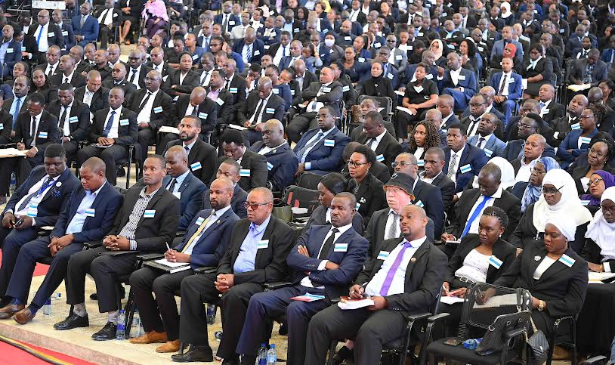

**State Attorneys following the Proceedings of the Public Bar Association Conference at Jakaya Kikwete Convention Center - Dodoma on 29 September 2022**

Honesty and integrity. Professor Kabudi went on telling the State Attorneys to be honest, first to themselves by knowing their weaknesses and strive hard to turn them to strength. As well, being honest is to work within the limits and ambits of the law, rules, regulations etc. He added, lawyer with integrity will always tell the truth. Will be fair and will not be corrupt. He will be obedient to the government and will not abuse his power. Second, is to the institution. A lawyer with high moral and integrity will not victimize innocent people. Hence legal profession is not for one whose integrity can be brought into question.[3]

Secrecy is among the ethical codes for lawyers and indeed state attorneys. Due to the nature of conduct of their duties they are exposed to as much as classified and non – classified information. Any indulge of the same without the need to tell and know, indeed without prior authority not only distort the credibility of an individual state attorney, also undermines the credibility of the profession itself. Moreover, this undesirable attribute for lawyers unclothe the institution.

Army as per the Constitution of the United Republic of Tanzania is barred from taking an active part in the politics save for the right to vote only. The same applies to the ‘Army’ of Lawyers. The Attorney General Judge Dr. Eliezer Mbuki Feleshi plainly and fiercely forbade all State Attorneys from any involvement in the politics. The reason is very simple and clear, being a State Attorney one is expected to be impartial in all senses of the word. Any attempt to get involved in politics implied or express may create a bias which is not a desired attribute of a state attorney.

As a way of wrapping up, suffice to quote Dr. Damas Ndumbaro who underscores, “To be a learned state attorney it not a complement but rather a burden to bear. One should be a constant reader. This is the genesis of being addressed as a learned one.” Thus, a learned state attorney who is not in love and dearer of books is in a wrong fraternity of books fond profession. Dr. Ndumbaro further delineated, “Being a state attorney is a prestige and reputable authority beyond compare. His one word is capable of saving the society.” Blatantly, these words call for the just use of their pen, papers and the words of the mouth.

1. Luoga F (2022*) Umuhimu aa Tasnia Ya Sheria (Mawakili Wa Serikali) katika Kuleta Maendeleo ya Taifa*, APaper Presented at Public Bar Association at Jakaya Kikwete Convention Center - Dodoma on 29 September 2022
2. Mwandosya M & Mwapachu J (2022) *38 Reflections on Mwalimu Nyerere*, Mkuki na Nyota Publishers Ltd, Dar es Salaam
3. Shivji, I. & Majamba M (2011). *Rules of Law vs. Rulers of Law*, Mkuki na Nyota Publishers Ltd. Dar es Salaam.